'Remember, remember the fifth of November'

Guy Fawkes' notoriety continues through the British celebration, futuristic movie
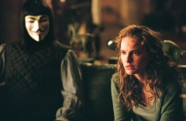
MCT PHOTO Hugo Weaving as "V" and Natalie Portman as "Evey" in "V for Vendetta."
The movie focuses around a character who idolizes Guy Fawkes, a persecuted Catholic who planned to blow up the English Parliament on Nov. 5. Bonfires and elaborate firework displays will be started across England tonight to commemorate one of the most notorious terrorist plots in British history. Known as the "Gunpowder Plot," Nov. 5, 1605 marks the day that a former soldier Guy Fawkes was caught in the basement of Parliament with 36 barrels of gunpowder in a scheme to blow up the building, the king and all representatives inside in an attempt to restore Catholicism in England.
Although notorious in England, in America, Fawkes is synonymous with the graphic novel made movie, "V for Vendetta" (2006). In a futuristic take on Fawkes, the main character "V" wants to blow up Parliament in an effort to overturn the government.
[…] Religious tensions in England between Catholics and Protestants were at their height when the Protestant King James I succeeded the throne, Professor DeSilva said. Just before Parliament was to be officially opened, guards were tipped off about explosives that would detonate killing the king and the House of Lords. When they investigated, Fawkes was caught, and he and the 12 other conspirators were later executed.
Now known as "Guy Fawkes Day," or "Bonfire Night," effigies of Fawkes are sometimes burned in bonfires, and firework displays are used to celebrate the discovery of the plot. Not only is this an exciting celebration for Britons, but it is also one of the fire department's busiest times of the year, according to the Associated Press. The Fire Brigades Union had said that its members would walk out from Friday to Sunday over a dispute over contracts. However, the strike was called off yesterday because of public safety concerns. `
[…] "Now, when Parliament opens at Westminster every fall, a ceremonial ‘searching of the basement' is held to make sure no explosives are there. King James I declared Nov. 5 [the day the explosives were discovered] as a celebration day, since the plot was discovered."
Read more: http://www.bsudailynews.com/features/remember-remember-the-fifth-of-november-1.2395263
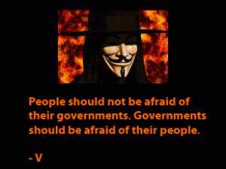
V for Vendetta was a comic book series written by Alan Moore. It was adapted into a Warner Bros Hollywood movie in 2006. The comic book had a depiction of a near-future Britain post a nuclear war that ravaged the whole world. In that future a fascist party by the name of ‘Norsefire’ which kept its opponents in concentration camps ruled the world. A mysterious revolutionary who called himself V worked to annihilate the dictatorial government. […] He had a shrewd and charismatic personality and character which stood for justice and individuality. He hoped to reform a society which was under the throes of corruption and oppression.
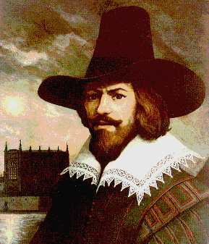
Read more: http://www.timesoftheinternet.com/briefs/v-for-vendetta-quotes-generating-interest-worldwide/
Guy Fawkes (13 April 1570 – 31 January 1606), also known as Guido Fawkes, the name he adopted while fighting for the Spanish in the Low Countries, he had belonged to a group of Roman Catholic restorationists from England who planned the Gunpowder Plot of 1605. Their aim was to displace Protestant rule by blowing up the Houses of Parliament while King James I and the entire Protestant, and even most of the Catholic, aristocracy and nobility were inside. The conspirators saw this as a necessary reaction to the systematic discrimination against English Catholics.
The Gunpowder Plot was led by Robert Catesby, but Fawkes was put in charge of its execution. He was arrested a few hours before the planned explosion, during a search of the cellars underneath Parliament in the early hours of 5 November prompted by the receipt of an anonymous warning letter.
Guy Fawkes Night (or "Bonfire night"), held on 5 November in the United Kingdom and some parts of the Commonwealth, is a commemoration of the plot, during which an effigy of Fawkes is burned, often accompanied by a fireworks display. The word "guy", meaning "man" or "person", is derived from his name.
From: http://momsword.org/index.php?option=com_content&view=article&id=9251%3Aremember-remember-the-5th-of-november-full-poem-quote&catid=1%3Alatest-reviews&Itemid=50&lang=en

Tip off: verb give insider information or advise to; "He tipped off the police about the terrorist plot"
Call off: verb cancel, postpone indefinitely or annul something that was scheduled; "Call off the engagement"; "cancel the dinner party”
Throe: noun hard or painful trouble or struggle; "a country in the throes of economic collapse" Adapted From: WordNet 2.0 Copyright 2003 by Princeton University. All rights reserved.

